iOS Data Storage Assignment (NFFileManager & NSKeyedArchiver)

Pooja Shah 010828311

Learning Objectives: Use iOS NS File Manager and its dependent classes & NSKeyedArchiver Classes

**Part 1: Use File handler to store iOS Data**

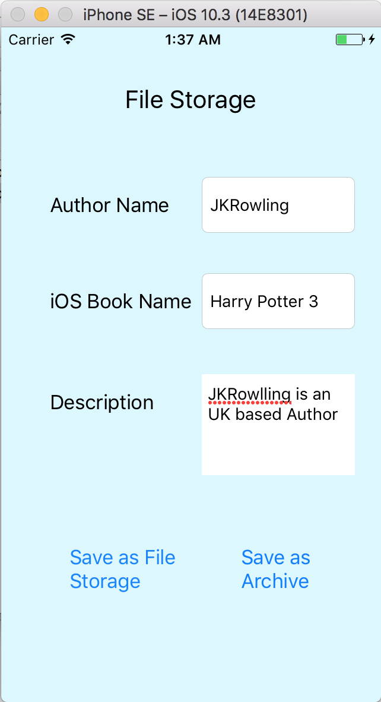

Fig 1. Entering Data

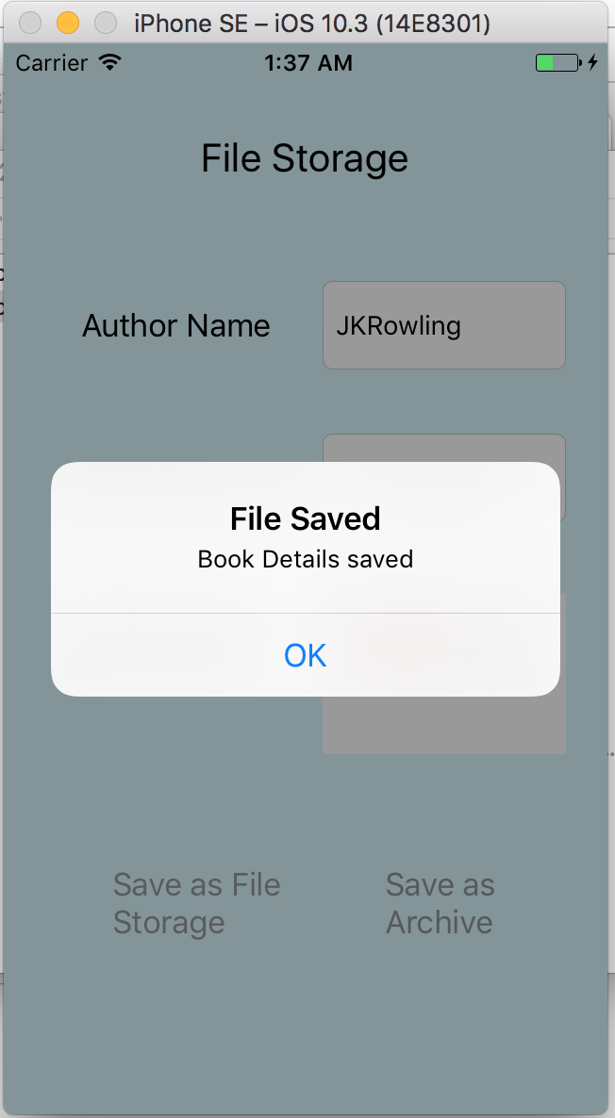

Fig 2. File saved

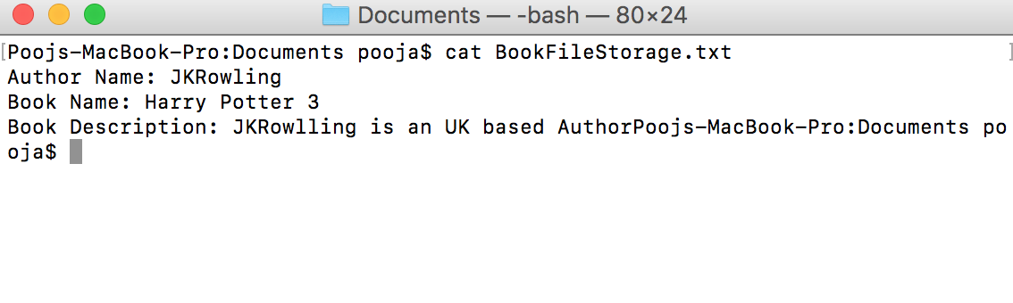

Fig 3. After saving data in file, data is saved as plain text

**Part 2: Use NSKeyedArchiver to store iOS Data**

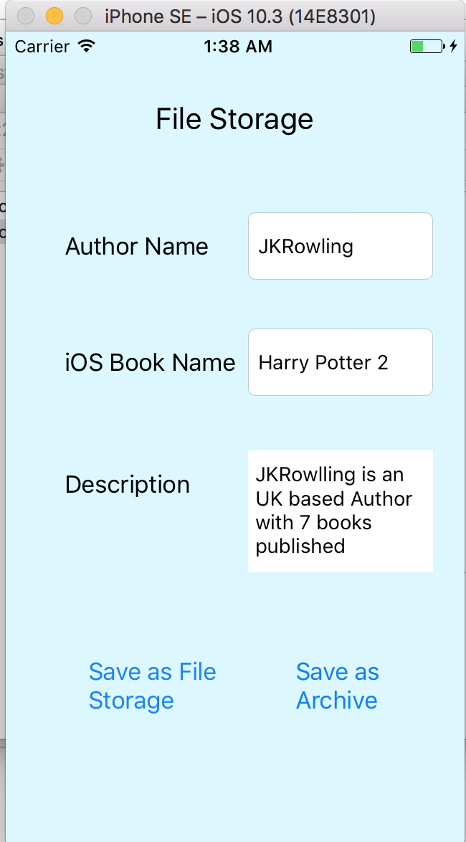

Fig 4. Entering information for Achieve

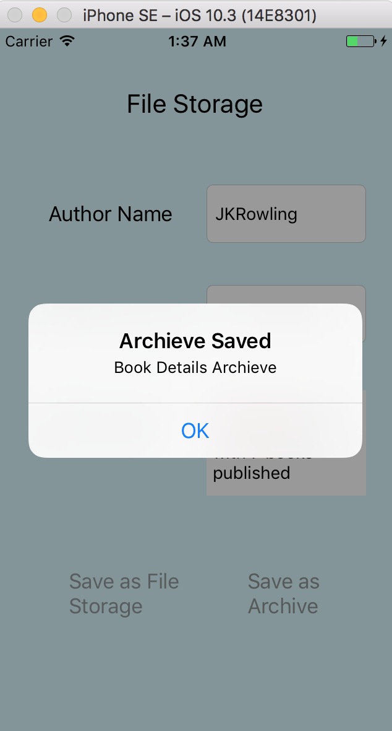

Fig 5. Achieve saved

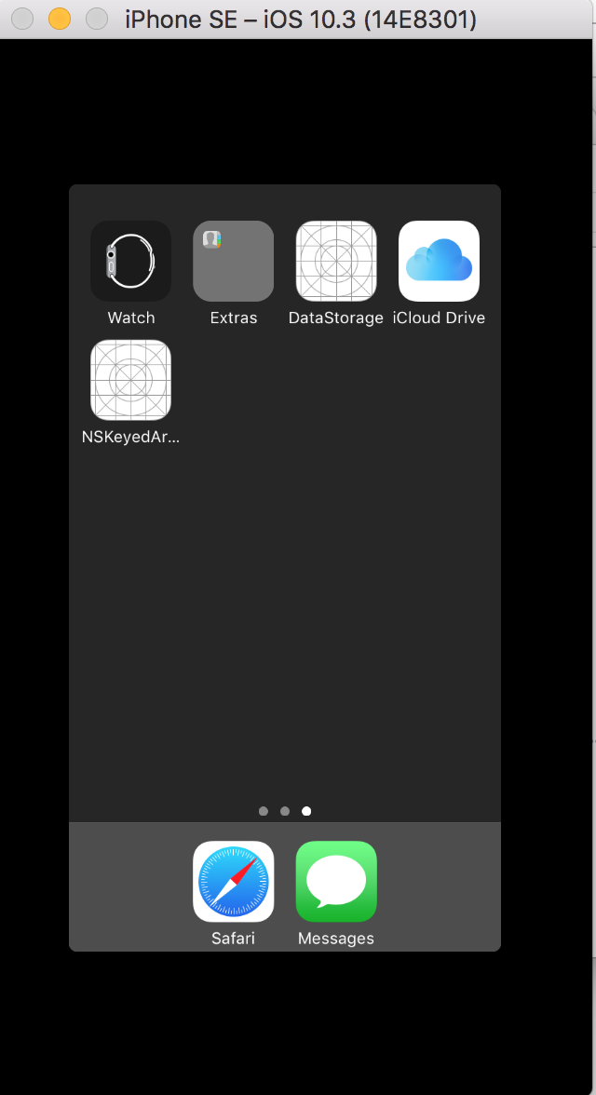

Fig 6. Destroying Application and not running in the background



Fig 7. After running the application again, data is appeared

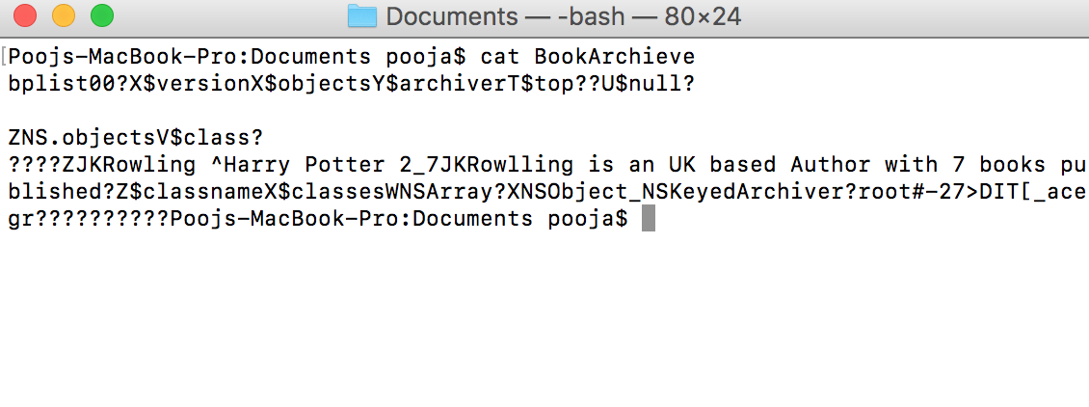

Fig 8. Achieved File (Encoded data)